Joy Tech Business Overview
Game. Earn. JOY!

Company Overview

Introducing Joy Tech
Joy Tech was founded with the mission to reimagine people’s relationships with hardware. The blockchain-enabled Web3 movement will revolutionise how people interact with digital property (e.g. money, collectables, and personalised AI) in one way or another. Despite the digital trend, humanity has proven that we yearn for physical manifestations of our identities. Consumers are far less likely to dispose of their beloved electronics, such as their Walkman, Game Boy, or iPhone, even if they become obsolete. We believe that people’s passion for the Web3 movement must have a corresponding physical representation in the form of iconic consumer electronics beyond Ledger and Trezor.

The problem we are trying to solve

Enter JOY, the GameFi hardware console, a portal for the next 100m gamers to join the growing world of Web3 Gaming. We offer a tangible service object where people can interact, collect, and compete all in a familiar form factor. JOY enables people to play top-tier on-chain games as well as simply sign or accept transactions through a familiar gamer’s UX. Our core value is to build a ‘crossover’ community of Web3 Natives and Gamers, a community strongly bonded by digital and physical representation. JOY defies the prevalent attention economy and toxic short-sighted business practices of modern gaming behemoths. With a return to simplicity, we seek to create beautiful hardware, a Web3 gaming OS, and a long-lasting cult-like brand following.

Why Now
- The AAA & AA Web3 games that fundraised in the 2021–2022 cycle have now launched or are in late-stage production, flooding the market with on-chain titles. More than one-third of Web3 investment is in gaming—and Joy’s GTM is perfectly timed to capitalise on this wave as the premier Web3 gaming handheld.
- Consumer electronics are going through a transitioning phase as Web3 & Gen AI are disrupting the incumbents. We anticipate that both crypto-curious consumers and crypto-natives will actively explore new forms of hardware companions beyond smartphones in this changing time.

Market Overview
Our mission is to create a crossover community within Gaming and Web3. From trend and community observation, we have identified the market gap below:

Console Sales (Current Generation)
Challengers - Steam Deck (3m+), ROG Ally (1.5m+)
Incumbents - Switch, PS5 & Xbox X/S (210m+)

Addressable Users (Traditional and Web3)
Challengers - 100m+ to be onboarded through 2028
Incumbents - 3.1b+ Web2 gamers (valued at $250bn)

Consumer Electronics Is Changing
Web3 - Ledger (6m+), Jambo Phone (400k+), Saga Mobile (35k+), Playtron
Gen AI - OpenAI, Pixel Phones,

There is no hardware on the market that meets the demands of modern gamers coming into Web3. Our goal is to create a device that hyper-targets Web3 Gamer's needs whilst offering traditional gamers their preferred entry point into Web3 as the market expands.

We envision that 10 million to 100 million gamers will be onboarded to Web3 in the next few years. The global active gaming population is 3.09 billion people while the Web3 users are at 400m. Joy expands the Web3 pie by offering GameFi their preferred entry point.

The new wave of gamers will naturally choose a more familiar form of hardware design when learning about storing digital collectables. Beyond gamers, we should be able to attract Millennials and Gen Zs who have first-hand experience interacting with console or handheld games. Therefore, Our addressable market should correspond to the number of gamers onboarded to Web3 and people with experience owning a gaming console.

Our immediate target demographic consists of 25-40-year-olds with high disposable incomes, aligning perfectly with the crypto-savvy population. As people are marrying later and extending their consumer activities, we anticipate sustained engagement within various communities, such as Joy (including gaming, brands, and other entertainment sectors), for longer periods than ever before. This presents a significant opportunity for growth and sustained interaction with a vibrant and dynamic audience.

Product Overview

Hardware

Design
- JOY Genesis is designed, sourced, tested, and manufactured in partnership with ePIC Blockchain, a circuit board design studio based in Toronto, Canada.
- JOY Genesis will resemble the Steam Deck/AYN Odin 2 with a 7-inch Gorilla Glass IPS screen, light body (approx. 700g), external camera, and EAL5+ grade security chip.
- Our design principle is to fuse the sleek designs of Playdate, Rabbit R1 (Teenage Engineering design), with the current leading Challenger Handheld Consoles (Ayn, AYANEO, etc.).
- JOY Genesis will be positioned as an upper-mid market entrant with successive versions targeting lower price points.

Hardware Specifications - subject to iteration
- Dimensions: ~22cm x ~10cm x ~2cm
- Weight: ~700g
- OS: Linux-based OS for Web3 Games
- Battery Capacity: ~8000mAh
- External Camera: 8MP
- WiFi Connectivity: WiFi 6
- CPU & GPU: Ryzen Embedded 7000 series and Ryzen Embedded 8000 series
- Memory / RAM: 256GB / 16GB
- Secure Chip Component: CC EAL5+ grade chip
- RRP: USD 549
Note: JOY is intentionally over-specced for future-proofing and high-end market positioning

Security Measures - 5 lines of defence
- Common Criteria EAL5+ accreditation from known info-security auditors
  - (commonly used by competitor hardware wallet providers)
- 3rd-party auditing and penetration testing from Web3 Auditing firms
- White hat bounty programs to community test the product e.g. ImmuneFi
- Apply existing open-source technologies for expedited GTM and trust purposes
- Leverage support and advice from angel networks to ensure best practice

Software

Web3 Gaming OS - accessible from both browser and device
The Web3 Gaming OS will be the primary OS accessible on JOY Genesis. This will be custom-built and will allow the device to play games created or ported with the Game Maker SDK (to be developed alongside the OS). These games will have a Web3 element in the form of NFT high scores, hot/cold wallet integration, and any other requirements of the current browser-based Web3 game meta.

To kickstart the gaming ecosystem, Joy will go to market with an established Web3 Gaming Ecosystem: Multichain by design. Joy is multichain at heart, partnering with a wide range of chains - including Somnia Network, Moonbeam, Solana, BNB Chain, Incentiv, and Hyperplay - to maximise the breadth of on-chain titles available on the device. Joy’s GTM activates this entire ecosystem, giving each chain partner consumer reach and giving Joy players the richest possible Web3 game catalogue from day one.

The Web3 Gaming OS is also an engagement and marketing tool enabling strategic ecosystem partners to create new games, incentivise the player base via token and stablecoin campaigns, and generate exciting trends with our GTM partners. This will ultimately create a viral marketing loop, contributing to device sales.

Web3 Game Library
Joy has partnered with a curated line-up of leading Web3-native game titles to launch on JOY Genesis. These include Star Atlas, Avalon, and World of Dypians. Players will be able to access on-chain assets, earn in-game rewards, and have their achievements recorded on-chain, with top scores and milestones surfaced on the Joy website leaderboards. The beauty lies in the community’s ability to discover and play an ever-expanding library of Web3 titles on their JOY device or on our website. Top games will be featured on the Joy Store (like the Apple App Store), allowing talented developers to make and monetise games for others to play.

Joy will run community hackathons to encourage the creation of said games, some prizes will be decided by community vote by verified owners of JOY devices or verified players of the games that own a high score NFT.

Game Maker SDK
The Game Maker Software Development Kit (SDK) will comprise a WebView module that links with Joy’s internal Wallet options, allowing developers to port browser-based Web3 Browser games to JOY with minimal cost or adaptation required. The SDK will later support more comprehensive porting of optimised Web3 games that run on specialised software platforms. This will become necessary as the industry matures and traditional game engines like Unreal, Unity, and Godot allow for Web3 elements.

We intend to work with established leaders such as Hyperplay and Somnia Network to expedite the SDK creation process and will work with our multichain ecosystem partners—spanning Solana, BNB Chain, Moonbeam, Incentiv, and Berachain—to optimise their game suites for Joy hardware.

The purpose of the SDK is manifold:
- To rapidly build out the suite of Web3 games available on Joy Genesis by porting existing web franchises.
- To allow the community to create engaging games for others to play, building out the Joy Tech ecosystem of games.
- To form the basis of B2C and B2B2C partnerships with the likes of Berachain, Yuga, Ronin, etc. This creates a hardware strategy for those projects in conjunction with their pre-existing brand, increasing awareness and, ultimately, sales of the JOY device.

Goy Tech System Architecture
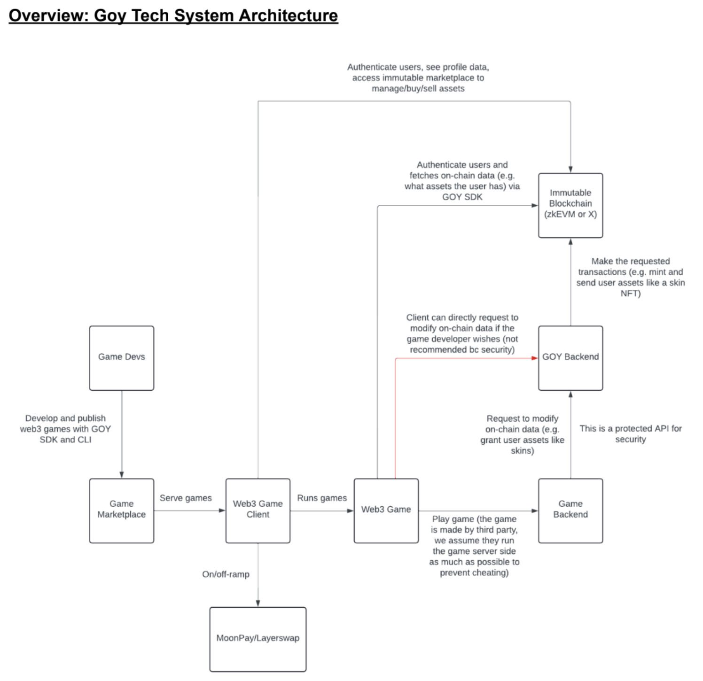
GameFi Framework
Summary: Games built on the JOY ecosystem need on-chain logic - the GameFi framework will handle this.

Immutable zkEVM
Allows smart contracts & is EVM compatible; however, users have to pay a small gas fee for transactions. This allows game-specific smart contracts to launch custom on-chain logic (Note: deploying smart contracts to mainnet requires approval by the Immutable team).
Docs: https://docs.immutable.com/docs/zkEVM/overview

Web UI
Summary: A site where users can play a demo game/other browser games and manage their accounts. The website can only enable users to play Web3 games intended for the browser.
Requirements: Users can see and manage their accounts, view account statistics, interact with the marketplace, and play the demo game. Users can also on/off ramp their assets to and from the platform.

Tech stack
- Next.js
- Creating signers through the Link SDK is required by Immutable for transactions.
- Web3Auth for social login to self-custodial wallets.
  - The private key needs to be exported and given to the Link SDK to create a
- Signer for the user
- MoonPay and Layerswap support on/off-ramp for Immutable’s chains

Client-Side OS & WebView App
Summary: The OS and WebView app are to be run on the handheld device to enable it to play games. The WebView app can only run games intended for the browser. Other games can be run through emulators or directly on Linux.

The WebView program will be able to run existing Web3 games intended for the browser and display the same login/logout flow, account info, etc. as the website. The user can also access the Immutable marketplace through the client.

Support for third-party game developers & non-browser games
Summary: Tools to enable game developers to create and publish games to the JOY ecosystem. While building their games, developers need to be able to access on-chain logic handled by Immutable and authenticate users through JOY. They also need access to building and publishing games through our marketplace. The client needs to use Immutable’s Javascript SDKs and run existing Web3 games, which are mostly intended for the browser (hence WebView is required).

However, if game developers want to create non-browser games, they would be forced to integrate on-chain functionality directly into their games, which creates a large barrier.

Solution: Rather than requiring games to be able to sign on-chain transactions, a Nest.js backend will mint and send assets to users on their behalf as they earn NFTs or other assets. Games can read the user’s assets from the blockchain without much overhead (see SDK for game developers below).

SDK for game developers
An SDK will help game developers create new Web3 games that are playable by the GOY
device.
- This requires an SDK and CLI for each supported game engine + for browser games.
- The CLI allows devs to compile and publish the game to the game marketplace.

The SDK feature requirements:
Login
- The SDK will include an API that authenticates the user and returns their wallet address. Immutable users are registered off-chain in a database. The backend will handle OAuth social logins and fetch the wallet address from the database.

Fetch users’ info from the blockchain
- The SDK will expose endpoints on our backend that fetch on-chain data (for example, skins or items the user has). This minimises the amount of blockchain logic required in the game.
- The SDK will expose endpoints for requesting transactions on Immutable.

Game engines
- Web - This SDK will be a wrapper around the Immutable zkEVM and their companion smart contracts. It will expose the required endpoints. This SDK will also support making transactions directly. Optionally, it will also expose the Immutable APIs for the asset marketplace. It can also wrap existing GameFi tools.
- Unity - Dev tools can be published on the Unity asset store
- Unreal - Dev tools can be published on the Unreal Marketplace
- Other engines, such as GoDot, can also be supported; this depends on necessity.

Ability to port existing non-browser Web3 games:
This will depend on the game and its infrastructure; roadblocks will be on a
case-by-case basis. Currently, most Web3 games are intended for play on the browser.

Hardware Wallet OS
At a high level, JOY Genesis UI/UX permits users to access two types of password-protected wallets: the ‘cold’ secure enclave wallet and the ‘hot’ software wallet.

Each OS module is isolated at the firmware level and cannot interact with the others, maximising security. The ‘cold’ wallet only permits access to the Hardware Wallet Companion Software. The ‘hot’ software wallet is a Whitelabel iteration of Web3Auth or other wallet-as-a-service powered by Social Logins/SSO. High Score NFTs, an iterated ENS smart contract, will let users store their NFTs in the ‘cold’ wallet, while securely playing the game using the ‘hot’ software wallet as an account. Transactions made through JOY-affiliated accounts are automatically protected using smart contract screeners like WalletGuard and Stelo.

Hardware Wallet Companion Software
The hardware produced by ePIC Blockchain will be coupled with an SDK to develop a firmware wallet on top, akin to Ledger Live/MetaMask. The firmware can be linked to other open-source applications that run on PCs/Smartphones/Browsers or integrated within MetaMask.

Within the software, auxiliary services can be accessed such as staking, swaps, on-ramping and off-ramping and WalletConnect.

Software Wallet Capabilities
- Connectivity with WalletConnect
- Connect with MetaMask through Windows/Mac/Smartphone via USB-C
- Scan and display QR code locally on the device (or enter the address via the on-screen keyboard)
- Locally generate Mnemonic phrases and wallet addresses through 2 or 3 sources of entropy (e.g. lights, software, and hardware)

Beyond On-Chain Games - DePin
JOY Genesis will be powerful enough to play all early Web3 game titles. The Joy ethos is to be as open as possible. We envision freelance weekend developers and gadget lovers freely modifying the hardware for purposes which could go beyond gaming. Moreover, Joy will be open to partnering with upcoming titans in the growing DePin sector who wish to use Joy or modify our hardware for DePin use cases. Some of these use cases could be using JOY Genesis as a light node client or an archive node. With the DePIN ecosystem comprising 650+ projects with a $35 billion total market capitalisation, Joy will be primed to target this sector as it matures through 2027 and beyond.

Business Overview

Roadmap and Go To Market
We will accelerate our GTM by working with experienced partners that will enable us to build the software and hardware in parallel using existing device shells that will be modified to our specifications. Business Development and Community Growth will also be conducted in tandem to strengthen the brand story and distribution channels.

GTM Phases
Phase 0 (Months 0-18): Bootstrap & GTM
- Product: JOY Genesis + Genesis Presale NFT Pass; launch game partners Star Atlas, Avalon, World of Dypians across multichain ecosystem (Somnia, Moonbeam, Solana, BNB Chain, Incentiv, Hyperplay)
- Business Model & Distribution: Online B2C, B2B2C
- Target Community: Web3 Natives
- Cumulative Devices Shipped Target: 20,000+
Phase 1 (Months 19-36): Hyperscale
- Product: + JOY Pro/Lite, Web3 Game SDK
- Business Model & Distribution: + Retail Storefronts
- Target Community: Web3 Natives + Traditional Gaming
- Cumulative Devices Shipped Target: 75,000+
Phase 2 (Month 37+): Endgame
- Product: + Joy Consumer Electronics, Joy DePin, Joy Gaming Studio, JOY 2
- Business Model & Distribution: + Product Whitelabel, Licensing, Platform TX fees
- Target Community: + General Consumer
- Cumulative Devices Shipped Target: 150,000+

GTM (Branding, Sales and Marketing Strategy)
Branding, sales, and marketing can be understood in the context of the 2 main verticals Joy targets: Web3 Natives, and Gaming (Web3/Traditional).

General Community Engagement:
We strategically participate in events that cater to our target audiences.
Online Presence: We actively engage with our community through a Newsletter, Discord server, and Twitter/X. Here, we will provide regular updates and interact with our audience (product feedback, hype, and community cross-pollination campaigns).
Offline Presence: We foster community building by participating in offline events like meetups, conferences, and competitions. This physical presence helps establish trust and credibility where people can experience the device in person.

Web3 Native Engagement:
Redeemable NFT Strategy: We have plans to implement a redeemable NFT strategy and vault projects in collaboration with partners like Courtyard, Americana, and IYK.
Community / Non-Digital Partnerships: We will collaborate with Web3 gaming and NFT communities that lack physical strategies, such as Berachain, Pudgy Penguins, Yuga, and others.
KOL Collaborations: We work with opinion leaders and influencers within the Web3 Native space to reach a broader audience and establish trust.
Regional Ambassadors: Regional Ambassadors will be employed and offered a budget to achieve localised community growth with region-specific KOLs. The community hire will manage these.
Hackathons: Create new games to be played on the device, and earn incentivised rewards if your games are the most played.
Security Assurance: To maintain the utmost security, we will conduct penetration tests through audit partners like Slow Mist and Quantstamp, aiding the wallet aspect of the brand. Optimisation: We continuously optimise our products and services using techniques like AB testing, alpha modes, and bounty programs to gather prototype feedback. Community co-creates the device with us.

Gaming Engagement:
Partnerships: Before GTM, Joy will have a lineup of partners for game development (like Immutable X) and also for building games (allocation offered to GTM game studios + our Gaming Angels will deploy their ecosystems to build on Joy)
KOL Collaborations: Influencers within the Gaming space to reach a broader audience and establish trust.
Custom Device Skins: We offer device skins featuring fashion brand logos through collaborations with brands like dbrand, allowing for a personalised touch.
Collaboration Thematic Game Launches: We're planning thematic games with partners to leverage their brand IP (e.g. Yuga Labs-themed Space Invaders, Axie, Candy Crush, etc.)

In sum, our approach combines a comprehensive online and offline presence with strategic partnerships, influencer collaborations, and a strong focus on security and optimisation to create a robust and trustworthy community engagement strategy.

Pricing Model
JOY Genesis is priced at USD 549, directly competitive with the leading handheld gaming devices of 2026: the Steam Deck OLED (USD 549), Legion Go S (USD 549), ROG Xbox Ally (USD 599), and Nintendo Switch 2 (USD 449). These competitors have built strong communities through Web2 marketing alone - Joy’s Web3-native tokenomics, on-chain reward loops, and ecosystem partnerships give it a meaningful differentiation at the same price point. JOY Genesis carries an estimated BOM of USD 400–415, reflecting its premium component specification and EAL5+ security chip, with Joy’s tokenomics strategy designed to subsidise early units and drive initial volume.

Joy’s tokenomics are centred around maximising device sales and establishing Web3 gaming partnerships to bootstrap the first 100,000 users and build the ecosystem. We will incentivise early buyers with tokens and effectively distribute the consoles at/or below manufacturing cost.

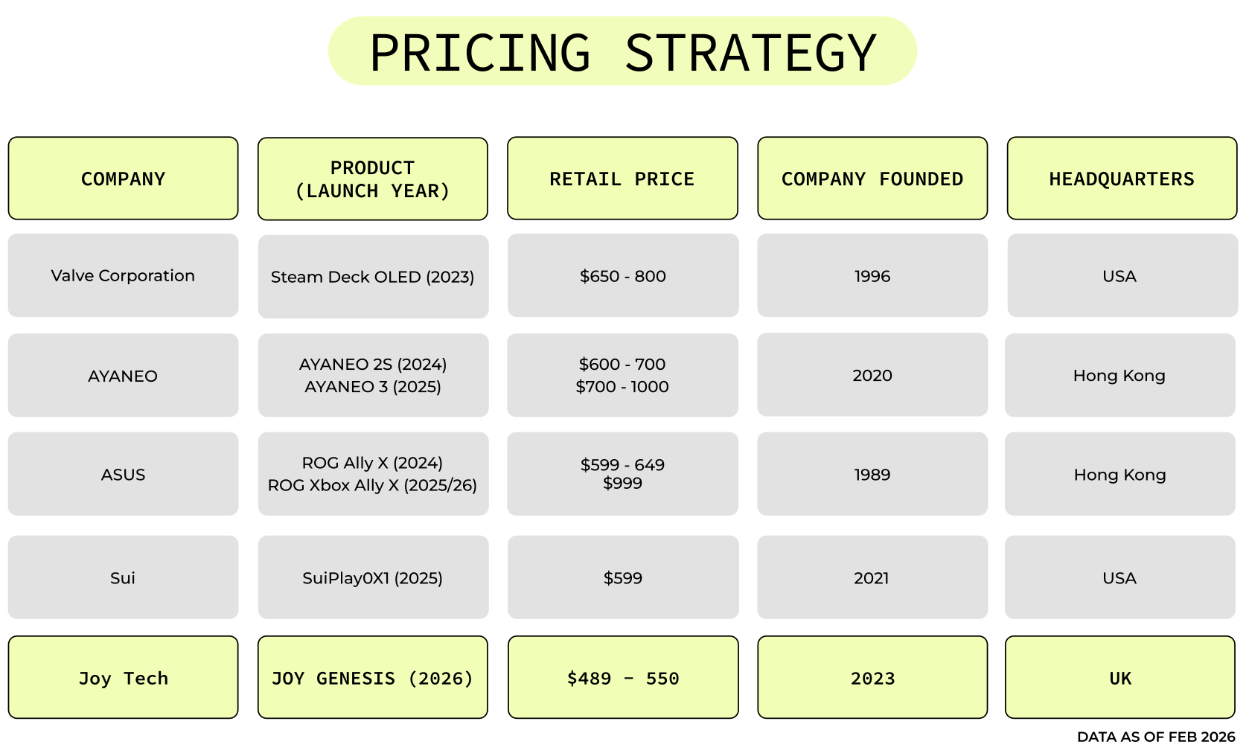

Team & Ecosystem
Daigan Reid, Founder & CEO

Daigan is an experienced operator and employee #4 of Somnia Network, a Metaverse Gaming L1 initiated by Improbable ($750m+ raised), partnered with Yuga Labs (BAYC + CryptoPunks) and Edison (founded by @BoredElonMusk). Previously, Daigan spent 4 yrs Leading Community, Product, and the Ambassador Program at Vega Protocol. Vega has raised $60m+ and is a hybrid layer 1 for the permissionless creation of any derivative market (Futures, Perps). The project is backed by Pantera, Hashed, Arrington, Coinbase Ventures, and more.

Daigan was a Founding member and Executive Director of London Blockchain Labs, present-day Blocktech, now partnered with a16z. LBL hosted the BIDE Conference in 2019 with 500+ attendees, attracting Consensys, HSBC, R3, and EU policymakers. Daigan was the President of LSE Blockchain 2019-21 and completed research on Game Economics with primary interviews from Jeffrey Zirlin, Growth Lead, Sky Mavis (Axie Infinity) and Filipino families earning an income through GameFi.

Earl Mai, Head of Hardware

Earl is a seasoned professional with over 20 years of experience in ASIC and system design. Before ePIC, he served as Lead Architect at AMD, demonstrating exceptional leadership and technical expertise. At AMD, Earl led a team of engineers in designing custom shader solutions for top-selling gaming consoles, including the PlayStation 4 and PlayStation 5, which have collectively sold approximately 140 million units worldwide.

Earl’s career is marked by a relentless drive for innovation, particularly in the gaming industry. His contributions to the development of GPUs at AMD have played a pivotal role in enhancing the gaming experience for millions of players globally. Earl worked on five generations of GPUs, focusing on advanced semiconductor technology from 32nm to 7nm process nodes. His expertise in GPU design has been crucial in delivering high-performance graphics solutions that are the backbone of modern gaming. Earl’s work has significantly advanced the capabilities of gaming consoles, making him a key figure in the industry.

Pral Bhojak, CTO
Pral Bhojak is an experienced ASIC Design and Design Verification Engineer with a strong background in semiconductors, specialising in Verilog, VCS, Verdi, UVM, TCL, Perl, Matlab, C++, and Linux. He has comprehensive knowledge of the IP product pipeline and significant experience with FPGAs and accelerated simulations. With over 8 years in video processing/multimedia and AI / Deep Learning, he excels in creating implementation solutions across functional models, RTL, and design verification. He holds a Bachelor of Applied Science with Distinction in Electrical, Electronics, and Communications Engineering from the University of Waterloo.
Daren Tung, Head of Supply Chain

Daren is a technical leader with extensive experience in mobile, blockchain, and Web3. After 15 years at IBM, he transitioned to the mobile app development space, leading and delivering award-winning apps.

As a co-founder at ePIC Blockchain Technologies, Daren leveraged his experience to support ePIC’s mission of becoming the leading ASIC and systems design-house for blockchain and PoW systems. Daren has also made significant contributions to the Web3 space, working on operations at Cirus Foundation and serving as an advisor for Helios. His diverse background and innovative approach have made him a key figure in the blockchain and cryptocurrency industries.

ePIC Blockchain, Hardware Partner
ePIC Blockchain are industrial engineers based in North America with a passion for high-performance distributed systems. They have sourced and supported the circuit board design for an existing VC-backed hardware wallet project. ePIC Blockchain’s primary business is the design and optimisation of UMC (Universal Mining Control) and its firmware, a control board to orchestrate large-scale Bitcoin mining operations.

Their team includes CEO Jim Seto, the previous VP of Operations at Qualcomm and CTO Earl Mai, who worked on Radeon semiconductors for PlayStation 4 and 5 GPUs. They bring their expertise in semiconductor, system design, and gaming hardware to build the GOY Gen 1 device. ePIC has pledged to help with Gen 1 circuit board design, sourcing of secure component chips, and device prototyping.

Full partnerships with ePIC Blockchain include and are not limited to;
- Brainstorming & Setting the Vision
- Procurement of Design Files, Bill of Materials (BOM) Compilation
- First Prototype Development
- Second Prototype Enhancement & Implementing Additional Components
- End-Product Audit & Security Certification
- Manufacturing Set Up, Pilot Production, Enforcing Quality Assurance
- End-User Delivery Network Support

Chain Partners
Joy is multichain at heart, partnering with a diverse range of blockchain ecosystems to give players access to the widest possible selection of on-chain games and assets. Our chain partners span grant-backed L1s and L2s through to established mainstream networks, ensuring Joy players benefit from every major Web3 gaming ecosystem in one device.

Somnia Network: a Metaverse Gaming L1 backed by Improbable ($750m+ raised), providing ultra-fast throughput optimised for gaming. Grant-backed partner.
Moonbeam: an EVM-compatible Polkadot parachain, enabling cross-chain interoperability for Joy’s game catalogue. Grant-backed partner.
Solana: a high-performance L1 with a thriving gaming and NFT ecosystem, actively integrated on Joy.
BNB Chain: one of the largest EVM networks by user activity and GameFi volume, actively integrated on Joy.
Incentiv: a Web3 growth and incentives network powering token-based player reward campaigns on Joy.
Hyperplay: an EVM aggregator and game launcher that extends Joy’s reach across the EVM ecosystem, supporting SDK development.
Berachain: Joy’s incubation-origin partner and a high-performance EVM-compatible blockchain, having raised a $100m Series B at a $1.5bn valuation (led by Brevan Howard Digital and Framework Ventures). The Berachain ecosystem, including games such as Beratone and the Build-A-Bera incubator, remains a key part of Joy’s early game catalogue.

YGG, Gaming Guild Partner
Yield Guild Games (YGG) is one of the world’s largest Web3 gaming guilds, with a global community of players and scholars across leading blockchain games. Joy ran a co-branded quest campaign with YGG in December 2025–January 2026, offering 500 whitelist spots and 1,500 USDC in player incentives. The campaign drove significant early awareness and established YGG as a key community pipeline for JOY Genesis device sales and player onboarding.

Corporate Details
UK Company Registration Number: 15024880

https://find-and-update.company-information.service.gov.uk/company/15024880

